**IPAT Java Version**

**9/8/2011**

**Work Done**

* IPAT skeleton application UI similar to original IPAT, see screenshots below.
* IPAT dummy functionality using dummy DLLs

**To be done**

* Creating DLLs of CSS application code
* Integration of functional DLLs to application
* *Creating client/server architecture for the desktop application (if time permits)*

**Screenshots**

1. When the application starts it searches for profiles in a predefined directory and looks for a predefined number of profiles, no of profiles can be altered. If available profiles are less than the required number, application generates random profiles to complete required count.

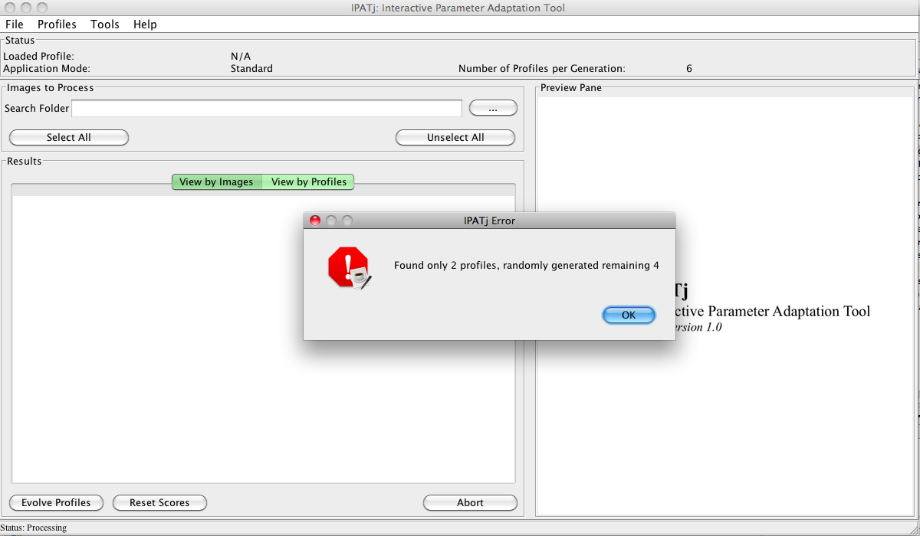

2. Profiles and options can be altered using the application menu bar.

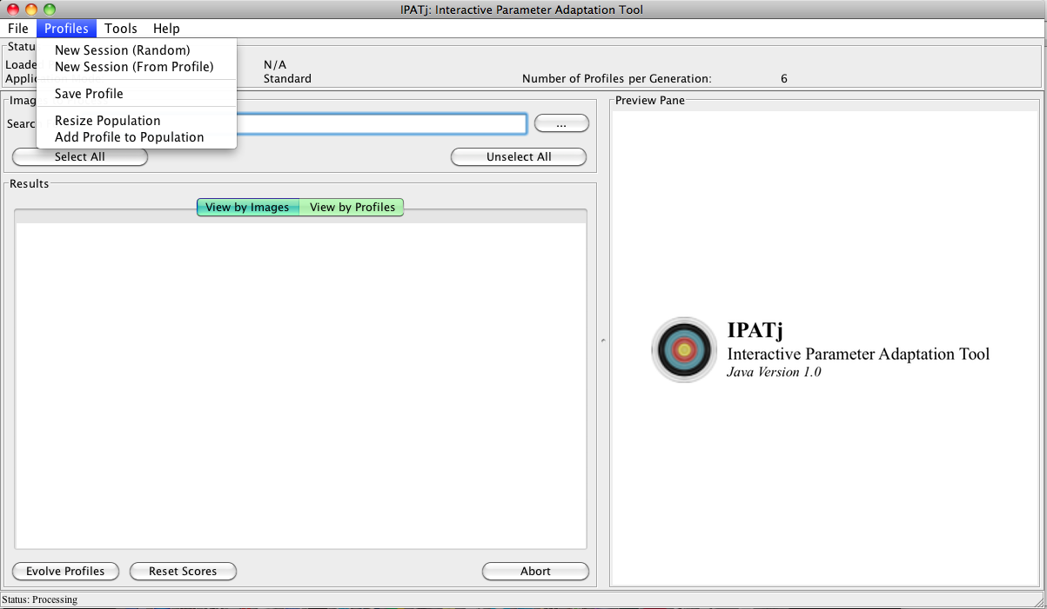

3. Once loaded, user can browse local directory to select ‘html’ or ‘png’ files.

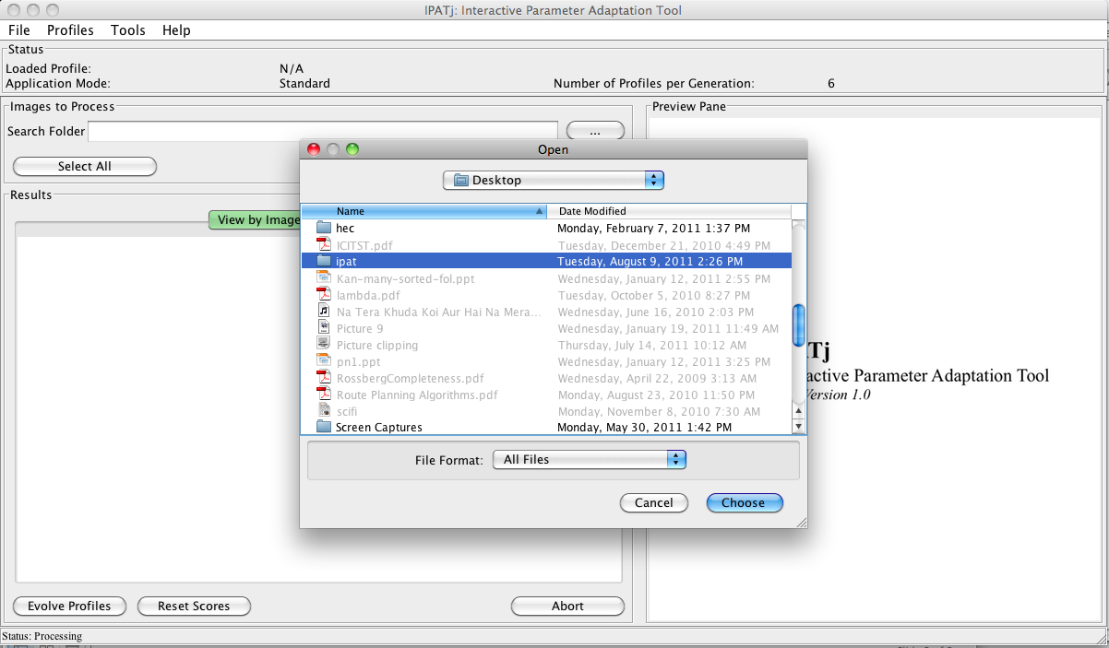

4. Once selected the application loads available ‘png’ or ‘html’ files, from which, user can select one or all or multiple.

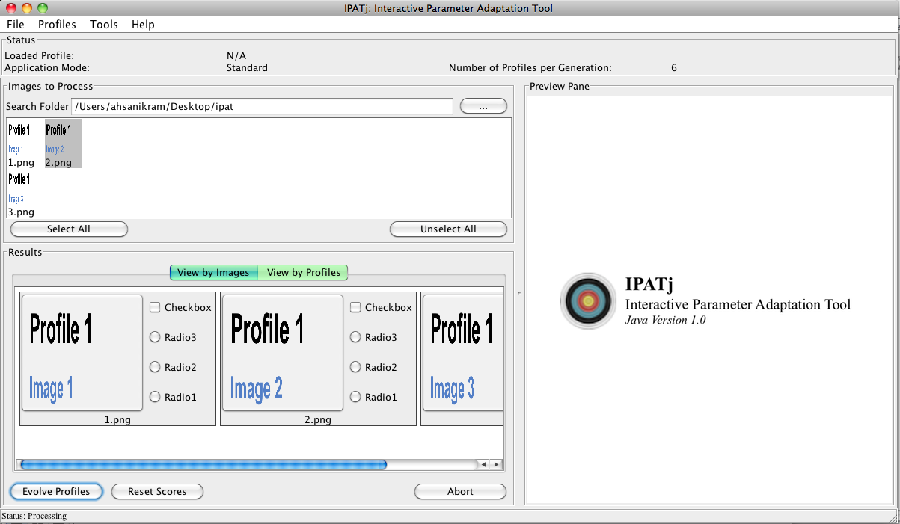

5. ‘Evolve profiles’ at the moment contacts a dummy DLL for processing and simply copies the original images to the results and output directory. User can provide feedback using the radioboxes dynamically added to the images. If the user clicks on a results item it is loaded in larger size in ‘Preview Pane;.

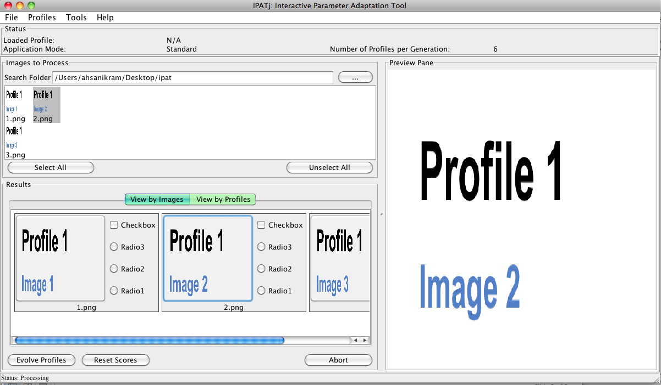

6. At the moment XML files, as shown below, are being used to define hints and their values, developer can dynamically opt for radiobuttons, checkboxes, textfields etc without needing to compile or change the code. However, if the core DLL application logic to be borrowed from original IPAT only supports text files, this version can be easily downgraded to use text files.

